Vulnerability Name- DNS Cache Spoofing (DNS Cache Poisoning)

Severity- critical

Vulnerability description- DNS Cache Spoofing is an attack in which false DNS records are inserted into a DNS server's cache. As a result, users requesting a legitimate domain name are redirected to an attacker-controlled IP address instead of the correct website.

Attack
Man-in-the-Middle (MITM)
Impacts-
- Users are redirected to malicious websites.
- Theft of login credentials.
- Malware distribution.
- Interception of sensitive information.
- Loss of trust in DNS resolution.
Steps to reproduce-
- Set up the Kali Linux machine and Metasploitable 2 machine on the same network.
- Verify that the target machine is reachable.
- Identify the DNS service running on the target.
- Perform the DNS cache spoofing assessment in the authorized lab environment.
- Observe whether the target accepts the spoofed DNS information.
- Document the findings and capture screenshots as evidence.
Proof of concept-
- Scan for target:
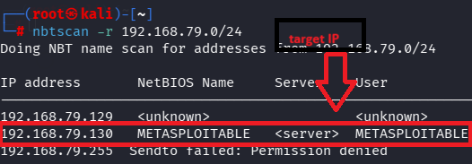
- Scan target:
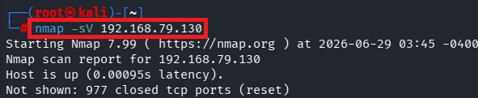
- Verify port:
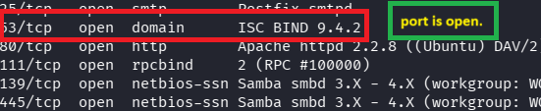
- Use of msfconsole:
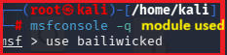
- Fill target details:
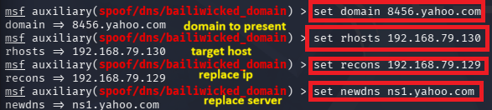
- Exploit: 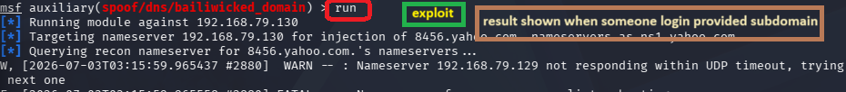

Remedy-
- Enable DNSSEC to validate DNS responses.
- Keep DNS server software updated.
- Use randomized source ports and transaction IDs.
- Restrict recursive DNS queries to trusted clients.
- Monitor DNS logs for suspicious activity.

References-
https://www.exploit-db.com/exploits/6122

